8x8 (16x16) Teensy Audio Board  
Technical Notes

V1.0 March 2025

*These notes should be read as an adjunct to schematics and datasheets. They are indicative of design choices but do not guarantee functionality or performance.*

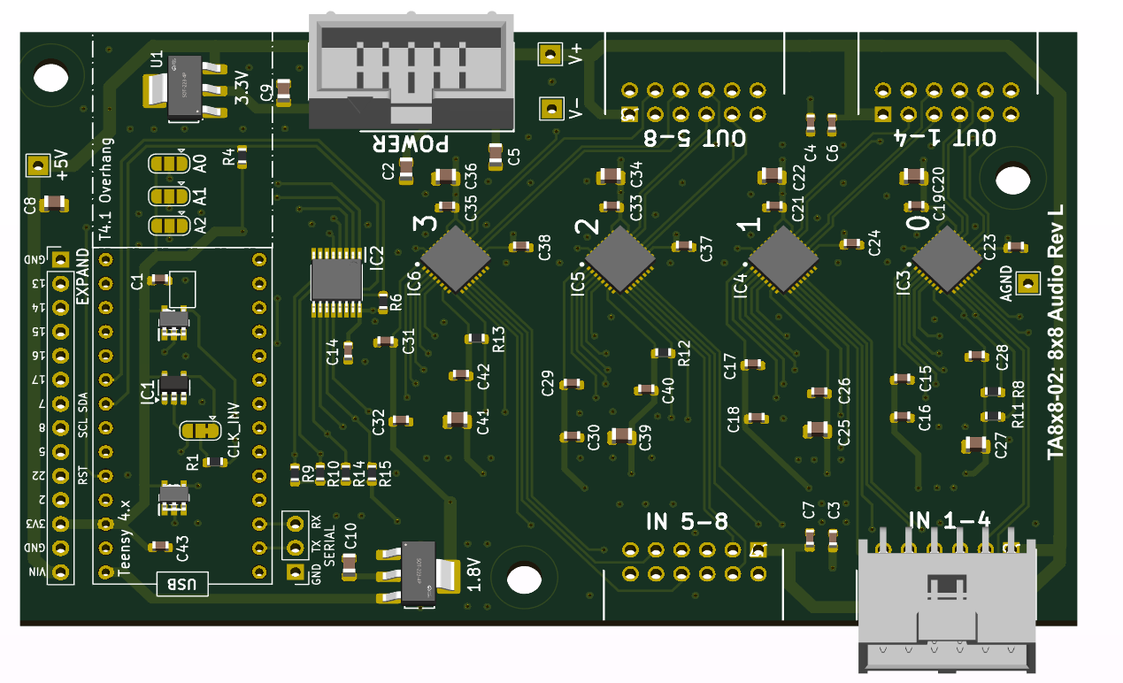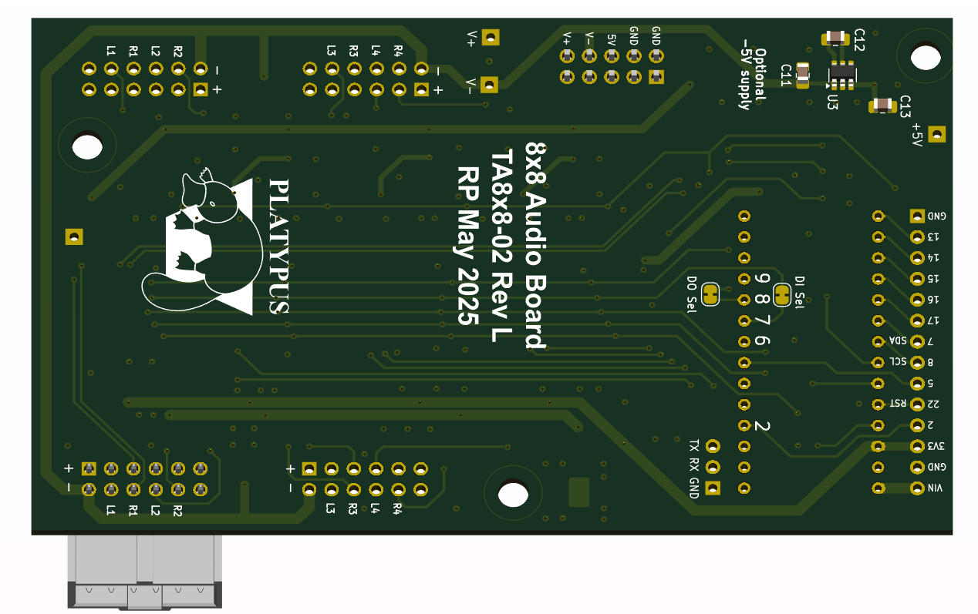

# Features

* 8x8 input and output channels
  + No input or output decoupling capacitors provided on main PCB.
    - Wing boards allow flexible mounting options for input and output connectors.
    - Wing boards have decoupling capacitors.
  + TLV320AIC3104 CODECs
    - TDM or I2S protocol
    - 16-, 24- or 32-bit samples
    - 44.1 or 48 kHz and multiples from 8 kHz to 96 kHz.
    - PLL capable when MCLK is absent.
* Two boards stackable (16x16) with standard Teensy TDM driver.
* Up to eight boards possible with advanced TDM drivers.
* Inputs
  + Balanced or single-ended.
  + Single-ended levels from 25 mVRMS (-60 dBm) to 0.71 VRMS (-1.5 dBm) using inbuilt PGAs.
  + Balanced levels from 50 mVRMS (-54 dBm) to 1.42 VRMS. (+10 dBm)
  + CODEC has inbuilt anti-aliasing filters on inputs and outputs.
* Outputs
  + 0.71 VRMS (2V p-p, +4 dBm) single ended or 1.42 VRMS (8V p-p, +10 dBm) differential.
  + Able to drive 16 Ω loads directly (30mW).
  + Amplified TRS wing board has x3 gain and can drive 600 Ω loads, but not low-impedance headphones.
* UART 1 is made available on a 3-pin header.
* Most unused pins are connected to a 14-pin expansion header, along with 3V, 3.3V power and the soft reset pin (22).
* A variety of input and output connector Wing boards
  + Designs are provided for 4-channel boards connected by 12-pin IDC cables.
  + All wing boards include electrolytic decoupling capacitors and anti-pop resistors.
    - ¼” TRS for input and output.   
      Two 1/8” stereo headphone sockets are provided for the output configuration.
    - ¼” TRS amplified output. 2.1 VRMS (6V p-p) single ended or 4.2 VRMS (12V p-p) differential.
    - XLR input and output connectors.
    - Phantom powered XLR input.
    - Combo XLR input connectors.

# Specifications

|  |  |
| --- | --- |
| **Item** | **Measure** |
| Output N+D (@ 90%) | 20-20kHz -92dB (differential) |
| Output Distortion (@ 90%) | 20-20kHz -93db  2nd Harmonic -98dB  3rd harmonic -95dB |
| Input N+D  (Line: PGA gain = 0dB) | 20-20kHz -96dB (differential)  THD (20-20k) 0.015% |
| Input N+D  (Mic: PGA gain = 59 dB) | 20-20kHz -68dB (differential)  THD (20-20k) 0.03% |

### Input channel Noise and Distortion

Measured with REW @ 937 Hz at -2dB FSD.

Results show quite good performance up to 30dB gain and tapering off after that. Dynamic microphones (~50dB gain) may be better served with a low-noise preamp.

|  |  |  |  |
| --- | --- | --- | --- |
| **Gain** | **N+D (dB)** | **Distortion** | **ENOB** |
| 0dB | -97 | 0.007% | 16.0 |
| 20dB | -96 | 0.02% | 15.8 |
| 30dB | -89 | 0.02% | 14.9 |
| 40dB | -82 | 0.02% | 13.6 |
| 50dB | -75 | 0.03% | 12.0 |
| 59.5dB | -70 | 0.07% | 10.3 |

# Notes

* When a *differential* input signal is applied to a CODEC programmed as *single-ended,* somereflection will occur into the other channel. This appears to be because VCM is connected to the negative PGA input in single ended mode, providing a path between channels (Fig 10-13, p.36).  
  To avoid this issue, program *differential* mode for all inputs for both single-ended and differential signals unless the CODECs negative input pins are not used (i.e. even pins on the input connector are left unconnected).   
  All wing boards should be programmed with *differential* mode.
* When *single-ended* mode is used, all negative input signals should be left unconnected.

# Hardware

The hardware is compatible with Teensy 4.0 and 4.1. It may work with Teensy 3.x but this is untested.

### CODEC programming

The TLV320AIC3104 CODECs have a single I2C control address, requiring I2C multiplexing for programming multiple chips. A PCA9546A I2C mux provides access the individual TLV320AIC3104 CODEC control registers. The mux has eight addresses (0x70 – 0x77) available, selected by solder jumpers for A0-A2, providing a theoretical limit of eight boards (64 channels) attached to a single Teensy. In practice, the standard TDM driver limits the number of channels to 16.

I2C pull-up resistance is provided for each board (3.3k R8, R10) and the selected CODEC channel (6.8k) in parallel. R8/10 values are set so that the pull-up is adequate when no CODEC is selected and the current does not exceed the 3mA I2C limit when a CODEC is selected. The per-CODEC resistors are sufficient to pull-up SDA and SCL on an unselected CODEC.

If more than two boards are stacked, the value of R8/10 may need to be increased to limit the overall pull-up current to below 3mA. R8/10 = 6.8k is suggested, but not tested, for four boards.

The CODECs and mux are hard reset by a signal from GPIO 22.

### Multiple boards

The MCLK, LRCLK (WCLK) and BCLK signals have 47 Ω series resistors on each board to provide impedance matching and to damp line reflections. When more than two boards are stacked, these may need to be increased to 100 Ω per board.

0R jumpers are provided for the DI and DO signals to enable alternate Teensy pins to be used in advanced TDM modes. Series resistors may be required to condition these signals when more than two boards are stacked. They are not required for 8x8 or 16x16 operation.

### 32x32 channel operation

DI and DO need to be re-mapped on boards 3 &4. Further details are in the Commissioning Notes.

### Inputs and outputs

All CODEC inputs and outputs have on-chip filters, so further external filtering is not required.

Inputs have individually-settable PGAs with 0 – 59.5 dB gain and can be configured as differential or single-ended.

The higher-powered headphone (HP) output drivers are used as they can drive 16 Ω loads to a maximum of 30mW. Digital output level controls are not implemented as mixer and level control objects are provided in the Teensy Audio library and many objects that can output have level controls.

The line (LO) outputs are not made available at on-board connectors to save space and PCB complexity.

### Optional -5V supply

An optional LM2776 -5V voltage converter is provided on the rear of the PCB connected to the V- bus. It is intended to be powered from V+ which has been jumpered from VIN. The supply is rated at 200mA and is intended to power input or output circuitry, as required.

-5V supply components are NOT populated on the standard PCBA configuration.

### Power consumption

Each board consumes around 100mA with unloaded outputs and the ADCs and DACs of all four CODECs powered on. The majority of this is from the 1.8V rail.

3.3V consumption will rise significantly when driving low-impedance loads.

### Audio input and output connectors

Inputs and outputs are grouped in sets of four and can be configured as differential or single-ended.

The shrouded 12-pin input and output headers share pinouts to allow flexibility in the provision of appropriate audio connectors. The same connectors are used on all Wing boards and are intended to be connected via 12-way IDC cables.

The channel numbering on the inputs and outputs is different. Pin 3 is the first positive input pin, and the last positive output pin. The ground and power pins are the same on input and output connectors.

### Audio input and output connector pin-outs

|  |  |  |  |  |  |  |
| --- | --- | --- | --- | --- | --- | --- |
| **Pin** | **Input** | **Output** |  | **Pin** | **Input** | **Output** |
| 1 | V+ | V+ |  | 2 | V- | V- |
| 3 | IN1+ | OUT4+ |  | 4 | IN1- | OUT4- |
| 5 | IN2+ | OUT3+ |  | 6 | IN2- | OUT3- |
| 7 | IN3+ | OUT2+ |  | 8 | IN3- | OUT2- |
| 9 | IN4+ | OUT1+ |  | 10 | IN4- | OUT1- |
| 11 | AGND | AGND |  | 12 | AGND | AGND |

|  |
| --- |
| **Connector types** |
| **Input and output (Main and Wing boards)** 2 x 6 pin 2.54mm shrouded right-angle male IDC header  Right angle connectors are required if stacking several boards. |
| **Power input** 2 x 5 pin 2.54mm shrouded male IDC header  Only on the board with the Teensy  Mounting a long-pin female header on the underside of the PCB allows power pins to stack. This is only required if V+ and V- are used. The Teensy headers transfers 5V power. |
| **Teensy and board interconnect**  2 x single row 14 pin 2.54mm female header  Long pins if stacking boards. |
| **Expansion**  14 pins, including 5V, 3.3V power, ground and pin 22 reset.  Pinouts are marked on the underside of the PCB |

### Expansion header

|  |  |  |
| --- | --- | --- |
| **Signal** | **Rev K** | **Rev L onwards** |
| **Pin** |  |
| VIN | 14 | 15 |
| GND | 13 | 14 |
| 3V3 | 12 | 13 |
| 2 | 11 | 12 |
| 22 RESET | 10 | 11 |
| 5 | 9 | 10 |
| 8 SCL | 8 | 9 |
| 7 SDA | 7 | 8 |
| 17 | 6 | 7 |
| 16 | 5 | 6 |
| 15 | 4 | 5 |
| 14 | 3 | 4 |
| 13 | 2 | 3 |
| GND | 1 | 2 |
| 23 |  | 1 |

GPIO Pins 2, 13,14,15 and 16 are uncommitted on the Expansion header.

The I2C bus and soft Reset signal are extended on the Expansion header as well as the Teensy header for boards.

An additional pin was added in Rev L to allow 32x32 operation. Other than that additional pin, the Expansion headers are compatible between revisions.

## Wing Boards

All wing boards, other than the amplified TRS board, are designed for through-hole components.

* 10uF or 100uF capacitors are 6.3 x 2.5mm, 10V or greater.
* 1uF capacitors are 5 x 2.5 mm, 10V or greater.
* Resistors are metal film, 5%, ¼ Watt.

All wing boards may be used in single-ended or differential mode. When used in single-ended mode, the coupling capacitors for the negative inputs should be omitted (see Fig 10-13 p.36) to allow these signals to float.

The 47 Ω series resistors limit the output current when an active signal is grounded, for instance on TRS output boards that may single-ended cables (i.e., ring is grounded).

### Combo

This input board has four XLR combo connectors (Neutrik NCJ6FI-H, NCJ9FI-H or REAN equivalents) with decoupling capacitors and discharge resistors to reduce pops when hot-plugging.

### XLR

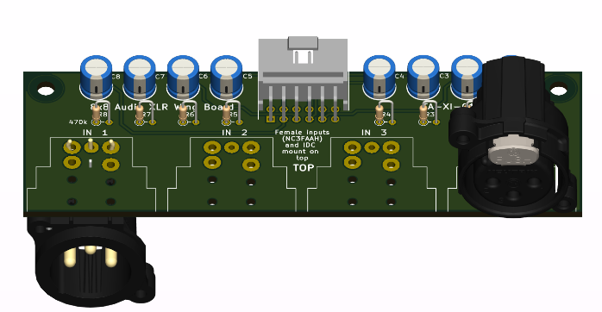The XLR board has four connectors – female for inputs (Neutrik NC3FAAH or equivalent, mounted on the top of the PCB) or male for outputs (NC3MAAH or equivalent, mounted on the underside of the PCB.)

The IDC header is always mounted on the top of the board.

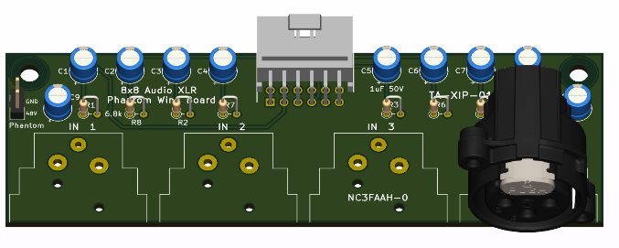The board has decoupling capacitors and discharge resistors to reduce pops when hot-plugging.

### XLR Phantom input

The phantom-powered XLR input board has four female connectors (Neutrik NC3FAAH or equivalent).

A 2-pin header is provided for an external phantom power source. 6.8k phantom power resistors are specified for 48V operation. The values may be reduced for lower voltages.

The board has 50V decoupling capacitors.

### TRS

The TRS board hosts four inputs or outputs.

The board has decoupling capacitors and discharge resistors to reduce pops when hot-plugging.

For *output* boards the 47 Ω current-limiting resistors R1-R8 are required to protect against single-ended (ring shorted to ground) cables.

For *input* boards the current-limiting resistors R1-R8 may be omitted and the pads linked.

The [Amphenol](https://au.mouser.com/manufacturer/amphenolaudio/) [ACJM-IH](https://au.mouser.com/ProductDetail/Amphenol-Audio/ACJM-IH?qs=t8VhaDIDl4v4EBLCsB4y7Q%3D%3D), [Neutrik](https://au.mouser.com/manufacturer/neutrik/) [NMJ4HFD3](https://au.mouser.com/ProductDetail/Neutrik/NMJ4HFD3?qs=%252B86TLfaev2%252B4Sd%2FGmMLlUg%3D%3D) or compatible switched TRS connectors are mounted on the top of the board for both input and output applications.

Note that the channel order is different for input and output use.

If grounding of unused *input* channels is desired, jumpers on the underside of the PCB may be shorted. The jumpers MUST be left open for output boards.

1/8” (CUI SJ1-353xNG) headphone sockets are provided in parallel to the ¼” TRS sockets. The current-limiting resistors are bypassed. *These are only required for the output configuration.*

### Amplified TRS

Where higher-level outputs are required for professional applications the Amplified TRS board provides an additional 3x gain. The maximum levels are 2.1 VRMS (6V p-p) single ended and 4.2 VRMS (12V p-p) differential. The board will drive 600 Ω lines to +8dBm, but is not recommended for low impedance headphones.

SMD components are used on this board to allow a more compact layout.

The LM2776 voltage inverter should be installed on the Teensy main board and Vin linked to V+. Alternately, suitable V+ and V- supplies may be provided via the Power connector.

If V+ and V- are greater than 5V, the gain may be increased to suit the op amps’ maximum output swing and drive capability. The maximum supply voltage of the op amps needs to be

# Teensy Audio Library AudioControl object

### AudioControl object

The driver for the I2C mux is incorporated into the control object and is invisible to end-user code.

The CODECs are set to select a specific 16-bit TDM slot (Reg 10) and tristate their outputs when not transmitting (Reg 8).

BCLK is inverted in hardware to avoid modifying the standard TDM driver further. This requires 1 bit to be added to the TDM slot delay.

On start-up the mux address range is scanned and 4-CODEC sets are assigned channel numbers in order of increasing mux address.

A verbose mode is available, with several levels of verbosity, for debugging.

The core functions have been tested substantially:

* 16-bit, 44.1 kHz, 8x8 and 16x16 TDM using the TDMA driver supplied.
* PGA gain using float dB or CODEC integer steps.
* Single-ended and differential inputs.
* Standard “Wire” I2C at 100kHz and 400kHz.

Several other functions have been included that have only had basic checks:

* I2S operation.
* PLL to replace absent MCLK.
* High-pass input filtering (zero offset removal).

Implemented and untested:

* TDMA and I2S input and output objects with sample lengths other than 16-bits.
* Sample rates other than 44.1 kHz and double rate operation.

CODEC capabilities not implemented:

* AGC
* Digital effects filtering
* Output level control (always set to 1.0). Duplicates existing Audio Library functions.
* ADC bypass functions
* Alternate mic-line inputs and MICBIAS.

## TDM driver

The standard Teensy Audio TDM driver (1.59) does not transfer odd channel audio buffers correctly. The TDMA driver supplied with the control object corrects this issue.

While the TDMA driver has an optional sample length argument, specifying 16-bits in the constructors is not required, as the default (32-bit) works with this hardware.

Jonathan Oakley’s Multi-TDM driver should also work with this hardware. <https://github.com/h4yn0nnym0u5e/Audio/tree/feature/multi-TDM>

The multi-TDM driver is required if more than two boards are stacked.